Guide to Starting a Business

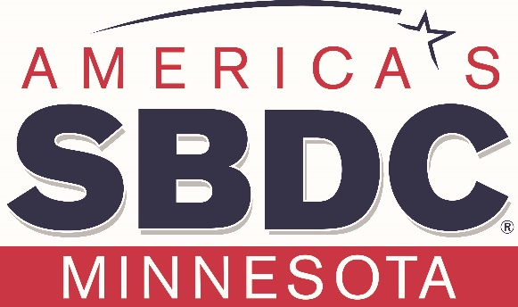

Northland SBDC
www.northlandsbdc.org
218-740-7307

Ask yourself these questions as you start to form your plan.

Financials Questions to answer:
- How much money is required to start the business?

- How much personal equity do you have to contribute to business start-up? Expect to contribute 20-30% of the total start-up cost.

- What will your monthly expenses be?

- What are your salary requirements?

- What are your proﬁt margins on each product you are going to sell?

- How much will you mark up your products?

Marketing Questions:
- What is the market?

- What is the growth potential?

- Who are your potential customers?

- How large is the market and what geographical parts of it will you cover?

- What are the industry trends?

- Who are your competitors? How are their businesses different?

- What are your competitive advantages?

- How will you price your product or service?

STEPS TO STARTING YOUR BUSINESS

- Start working on your business plan.
You can download our template at:
https://northlandsbdc.org/business-resources/#downloads

- Sign up for service at www.northlandsbdc.org and meet with a business consultant who will help you with your business plan, financial projections, finding financing and other resources.

- Determine the name and legal structure of your business: Proprietorship, Limited Liability Company or Corporation
Information on types of legal structures:
https://www.irs.gov/businesses/small-businesses-self-employed/business-structures

- Register your business name with the Minnesota Secretary of State.
https://www.sos.state.mn.us/
or call: (651) 296-2803 or 1-877-551-6767

- Secure appropriate local business license and permits.
Call your city clerk or go online to your city website.

- Obtain a Sales and Use Tax Permit.
Online at:
https://www.revenue.state.mn.us/guide/registering-your-business
or Call 651-282-5225 or 1-800-657-3605 (toll-free)

- Register for an IRS EIN number
Online at:
https://www.irs.gov/businesses/small-businesses-self-employed/employer-id-numbers
Or call 1-800-829-4933.

- Establish a business bank account
You will need your LLC and EIN to open an account.

- Acquire a domain name, print your business cards and issue press releases

- Choose a location.

- Self-employment taxes

Find information on Self-employment Taxes:

https://www.irs.gov/businesses/small-businesses-self-employed/self-employed-individuals-tax-center

- Hiring Employees
If you intend to hire employees visit:

Federal Regulations

https://www.irs.gov/businesses/small-businesses-self-employed/hiring-employees

Minnesota Regulations

https://mn.gov/deed/business/starting-business/basics/hiring-checklist.jsp

Online Resources and Training
Visit the SBA Website for their free Startup Learning Center: http://sba.gov
- Explore the site and visit the links for starting and managing.
- Go to https://www.sba.gov/sba-learning-platform for additional tools.
For Additional Resources, go to:
- https://www.irs.gov/businesses/small-businesses-self-employed/small-business-virtual-tax-workshop
- https://mn.gov/deed/

BUSINESS PLAN TEMPLATE

Download our business plan template:

https://northlandsbdc.org/business-resources/#downloads

Financial Projections
Download our spreadsheet templates at:
https://northlandsbdc.org/business-resources/#downloads

If you intend on financing your start up.

BANK LOAN CHECKLIST

- Business Plan
- Sources & Uses
- Current Business Debt Schedule (Existing Businesses Only)
- Three Years Company Tax Returns & Financial Statements
- Company In-House Interim Statements for year to day
- Three Years Projections, Cash Flow & Assumptions
- Copy of the Purchase Agreement
- List of Collateral & Estimated Values
- Personal Financial Statement (All 20% Owners)
- Three Years Personal Tax Returns (All 20% Owners)
- Personal Resume (All 20% Owners)
- Afﬁliated Company Information (All 20% Owners)
- Franchise Agreement (If Applicable)
- Company Articles, By-Laws & Registration Documents
- Copy of Drivers Licenses & List of Previous Gov’t Loans (For SBA Loans)
- Copy of Leases (If Applicable)

