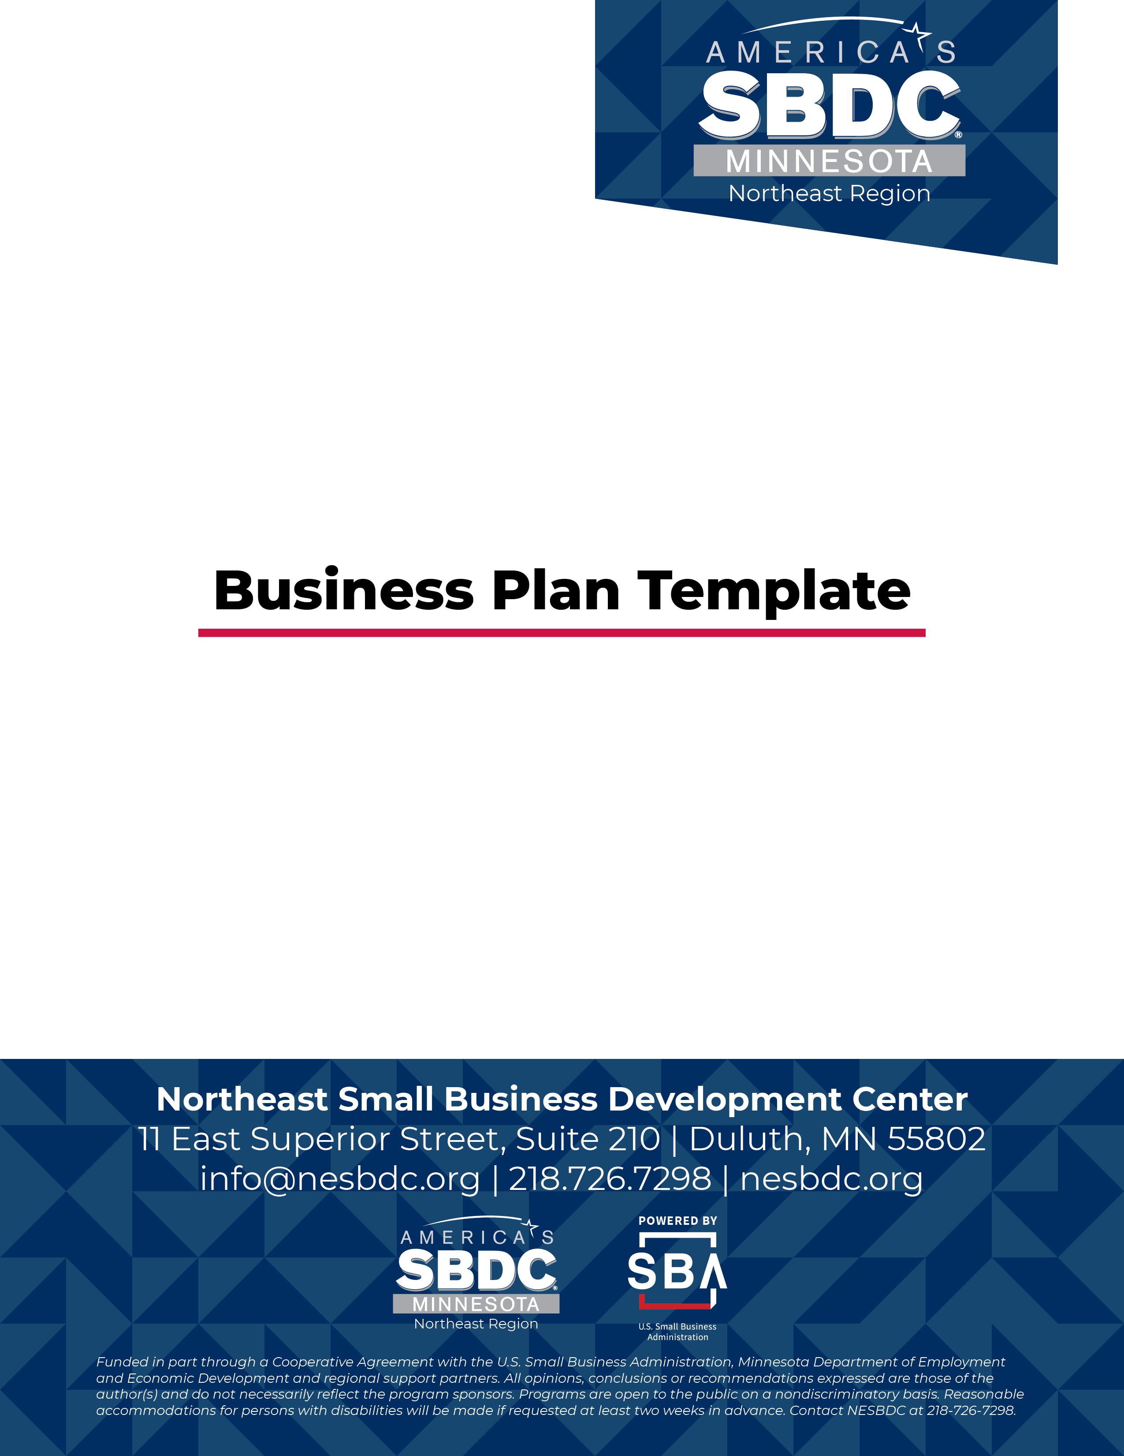
COVER PAGE

Put Business Name Here

Business Name:

Primary Business Contact Name:

Street Address:

City, State, Zip:

Work Phone:

Home Phone:

Cell Phone:

Fax:

Email:

Website:

TABLE OF CONTENTS

EXECUTIVE SUMMARY 3
BUSINESS DESCRIPTION 3
GOALS 4
SWOT ANALYSIS 4
INDUSTRY CHARACTERISTICS & TRENDS 5
CUSTOMER 5
COMPETITORS 6
SALES PROJECTION SUPPORTING DATA 7
MARKETING PLAN 8
SUPPORT PROFESSIONALS 9
FINANCIAL PROJECTIONS SUMMARY AND ASSUMPTIONS 9

EXECUTIVE SUMMARY

Written Last:

Brieﬂy Describe Your Business (One paragraph summary):

Legal Organization (LLC, Sole Proprietor, S Corporation):

Ownership (Enter name(s) of owner(s)):

Funding Request:

BUSINESS DESCRIPTION

Business Description (Provide a detailed description of your products, services, organization, operations and management):

Vision (What are your long-term aspirations?):

Mission (What do you do that helps you meet your vision?):

GOALS
Ensure that goals are S.M.A.R.T. – Speciﬁc, Measurable, Achievable, Realistic, and Timed
Short-Term Goals (less than one year):

Long-Term Goals (one year or more):

SWOT ANALYSIS

WITHIN THE COMPANY
Strengths:

Weaknesses:

OUTSIDE THE COMPANY
Opportunities:

Threats:

INDUSTRY CHARACTERISTICS & TRENDS

CUSTOMER
Demographics: Who are your customers? (average age, income, education, etc.)

Psychographics: What are your customers’ personalities, values, attitudes, interests, and lifestyles?

Geographic Area: What area do you serve?

COMPETITORS

Provide top 3 competitors with strengths and weaknesses for each competitor, feel free to add more.

- Business Name
Strengths:

Weaknesses:

- Business Name
Strengths:

Weaknesses:

- Business Name
Strengths:

Weaknesses:

SALES PROJECTION SUPPORTING DATA
Potential Customer Base:

National Trends:

Competitive Advantage:

Share of existing market to capture:

MARKETING PLAN
Social Media:

Customer Loyalty Program:

Website:

Internet Advertising:

Blog:

Newsletter:

Direct Mail:

Radio:

Newspaper:

Television:

SUPPORT PROFESSIONALS
CPA:

Attorney:

Bank:

Insurance:

SBDC Consultant:

Other:

FINANCIAL PROJECTIONS SUMMARY AND ASSUMPTIONS
See spread sheets

